**Belvoir Parish Council**

Jo Langford Yates Clerk to the Council

1 Back Lane, Harston NG32 1PN

Tel: 079 564 37175 E mail: [clerk@belvoirparishcouncil.org.uk](mailto:clerk@belvoirparishcouncil.org.uk)

**All Councillors are summoned to**

**An Ordinary Parish Council meeting will be held on Tuesday 21st January 2025 at 6.30pm at Knipton Village Hall**

**The public are invited to attend**

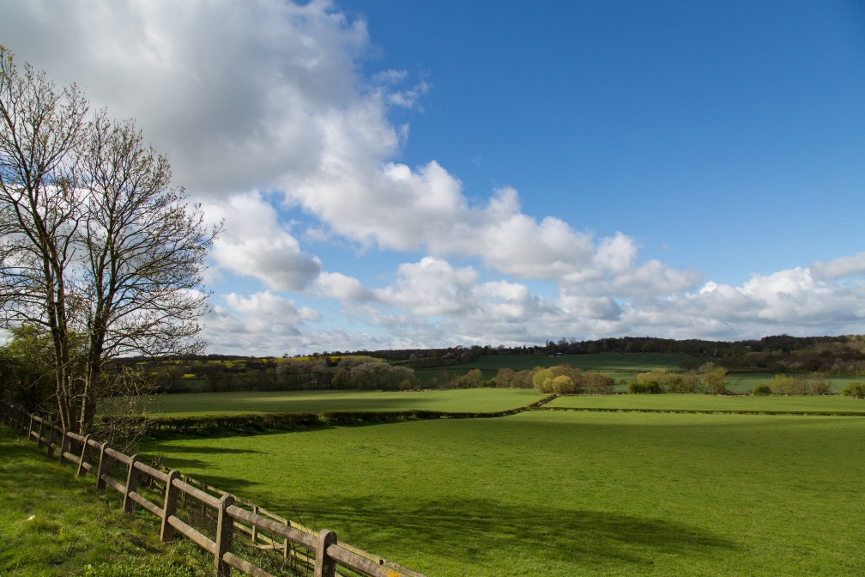

Ordinary Parish Council meeting

1. To elect a new Chair and Vice Chair
2. Financial, to approve & sign payments submitted.
3. Highways and traffic.
4. Street lighting – ongoing programme of replacement of SOX to LED bulbs, to agree further replacements.
5. Planning applications submitted and request from the appropriate authority any extensions necessary for consideration before the next meeting.
6. Flood warden/coordinator report for Knipton
7. Village Hall.
8. Street Furniture & Defibrillators – monthly risk assessment
9. Street furniture and asset maintenance
10. Churches Harston & Knipton
11. Crime and Neighbourhood Watch
12. Belvoir Estate matters to be discussed including planned & previous events. Care Homes within the parish.
13. Vale Parishes Group matters for discussion.
14. Correspondence for discussion
15. Further items for discussion
16. Recommendations for the next meeting.