BELVOIR PARISH COUNCIL
Minutes of an ordinary Parish Council meeting held at Knipton Village Hall on Tuesday 13th February 2024

Members present: Cllr Carr Chairman
Cllr J Marshall
Cllr Hazel Johns
Cllr C Haywood
Cllr Anna Griffths
Cllr M Porter
Clerk Jo Langford Yates

Attending: Luke Haigh - Keepers Cottage, Harston
Jacob Dunne – Belvoir Estates Community Officer
Anthony Haslam – Belvoir Estates Management
Ian Comerford – Harston resident
Tim Jones – Harston resident
Simon Tong – Eaton
Alan Hewson – Borough Councillor and Mayor

17.861 Declarations of Interest No declarations received.
17.862 Minutes from the January meeting were approved and signed.
17.863 Knipton village shop and Post office The Knipton village shop and Post office possible closure was discussed with the representatives of Belvoir Estates. The premises are owned by Belvoir Estates and the current tenants are faced with a substantial rent increase and have decided their current business model is unsustainable and will terminate their lease at the end of March. Concerns were raised by Harston residents Tim Jones and Ian Comerford particularly at the possible closure of the facility and have submitted a petition to the Belvoir Estates department. Belvoir Estates department manager Anthony Haslam addressed the concerns and confirmed there is a new tenant in talks with the Estate to continue the facility of a village shop, although at this stage it is unclear if the Post Office would continue. Anthony Haslam has promised to enquire with the proposed new tenant if the Post Office would be forming part of heir new business plan and report back at the next meeting. Concerns about losing a local facility which includes a satellite operation in Woolsthorpe would be a great loss the local community and surrounding villages.
17.864 Standing Orders There are no changes to the current standing orders and financial regulations
17.865 Financial The bank balance has been reconciled and stands at £6312.02. There is one payment to be made to LRALC for £200.00 audit fees. The clerk received the VAT return payment of £578.48 in December 2023.
17.866 Street Furniture and Risk Assessments. Cllr Griffiths confirmed the Knipton defibrillator is working correctly, Cllr Marshall confirmed the Belvoir defibrillator is working correctly, the Harston defibrillator is to be inspected by Cllr Carr and will be confirmed to the clerk.

17.867 Street Lighting no failures have been reported. The three lights to be replaced by LED lamps are No 12 at the Bus stop in Knipton which is unsuitable for conversion to LED and the clerk is expecting a quotation from Eon for a new pole and bracket. No 13 at 1 Church Hill & 9a Field opposite Granby will be replaced at £350.00 each.

17.868 Planning Application Keepers Lodge 23/00042/FUL – withdrawn 30th March 2023
Description : | Change of use of land for the siting of lodges, static caravans and tents for a tourism site on land to the rear of Keepers Lodge
Location : | Keepers Lodge Denton Lane Harston NG32 1PW.
Joe Daniels from Neauveau Financial Services representing Luke Haigh of Keepers Lodge, Harston presented to the council the proposed development of Keepers Lodge to evolve as Viking Park holiday complex to include the erection of four log cabins and ten static caravans for holiday letting through Hoseasons. This was an informal representation outlining the future submission of a planning application to Melton Borough Council for consideration. This will be reviewed formally by the council on receipt of the information.
17.869 Planning Application Belvoir Estates - Parish Belvoir Officer Katie Ferguson Case Ref : 23/01117/FUL Expected Decision Level DEL Expected Decision Date 29.01.24 Map Reference East481717 North333662 Mr ANTONY HASLEM Mr Richard Willow.
There were no objections from councillors.

17.870 Highways The Clerk has received the following results of the traffic survey recently carried out by LCC Highays.

Survey location | Speed limit | 85th percentile of speeds
Belvoir Road (on approach to the bridge over River Devon) – Northwest bound | National speed limit | 35.4mph
Belvoir Road (on approach to the bridge over River Devon) – Southeast bound | National speed limit | 31.9mph
Belvoir Road (at the change in speed limit*) – Northeast bound | 30mph | 31.3mph
Belvoir Road (at the change in speed limit*) – Southwest bound | 30mph | 31.6mph
Belvoir Road (centre of the village) – Northeast bound | 30mph | 28.1mph
Belvoir Road (centre of the village) – Southwest bound | 30mph | 27.7mph
Pasture Lane – North bound | National speed limit | 40.8mph
Pasture Lane – South bound | National speed limit | 38.8mph
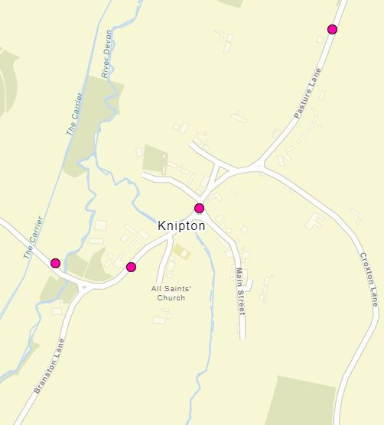
17.871 Belvoir Estates - representative Jacob Dunne is keen to expand his new role as Community liaison officer and engage with the local community on behalf of the estate.
17.872 Belvoir Estates residential properties – One to one care facilities -a number of residential properties in the surrounding villages belonging to the estate have been converted to care facilities and local concerns have been raised regarding an increase in nuisance. The matter of the properties now being operated as commercial with no transparent conversion from residential raises questions, this was put to the representatives of Belvoir Estates. The residential/commercial status is to be confirmed by the estate and Melton Borough Council. Cllr Johns has visited the facility in Knipton and reported this to be a minor operation with only two carers working on a shift basis. Cllr Johns is to pay a further visit to the facility at Woolsthorpe Lane Harston and report at the next meeting.

17.873 Crime & Neighbourhood Watch No reports within the parish. Cllr Hewson brought to the attention of the council the need to report all crime no matter how minor to maintain levels of rural police presence.
17.874 Harston & Knipton Churches there is nothing to report.
17.875 Village Hall There is nothing to report.
17.876 Correspondence and Reports The Clerk has circulated all correspondence to councillors.
17.877 Vale Parishes Group The Chairman is currently engaged as the representative for Belvoir Parish Council and has campaigned with local parish councils as a united body sharing and collating information in regard to major issues affecting local communities, in particular large scale events planned that have a major impact locally concerning drug abuse, noise, light pollution and traffic. Currently the Forbidden Festival event currently has been granted licence for 22,500 people attending over the weekend, an increase from 15,000 in 2023. The VPG group have gained a rapid wealth of experience and knowledge which will better serve to curb future plans for events in 2025 and beyond, where the target audience is 80,000 which will have a significant affect on the local community. The Noisily festival also planned as an annual event raises similar noise, traffic and drug abuse issues. The Chairman has put forward a representation to the MBC licencing committee after receiving complaints from within the parish. Event organisers are engaged with the VPG and Melton Borough Council and our Chairman will update Belvoir PC at all future meetings.
17.878 Further Business No further business

17.879 Next meeting The next meeting date was agreed for March 19th 2024 at 6.30pm

Clerk to the Parish Council Chairman

